ML Algorithms

Ridge regularization proof:

Dl/Db is same as we proved in previous algos as there is no change

And b comes out to be:

b = Ybar – m(Xbar), here Ybar = y mean and Xbar = X mean

Will focus on Dl/Dm:

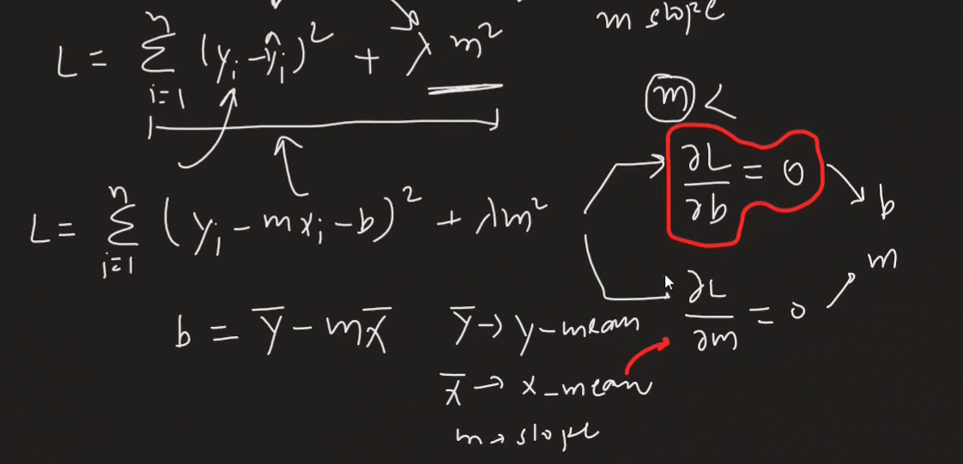

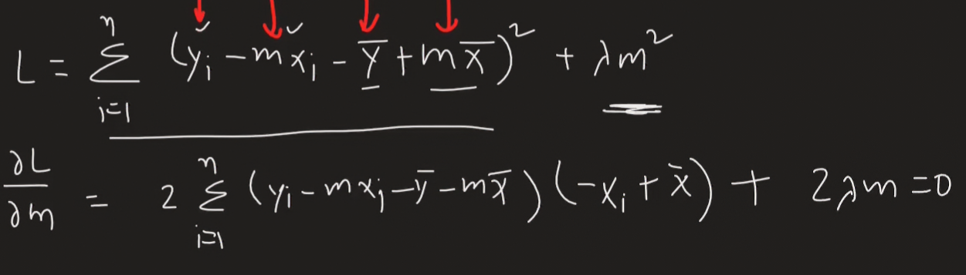

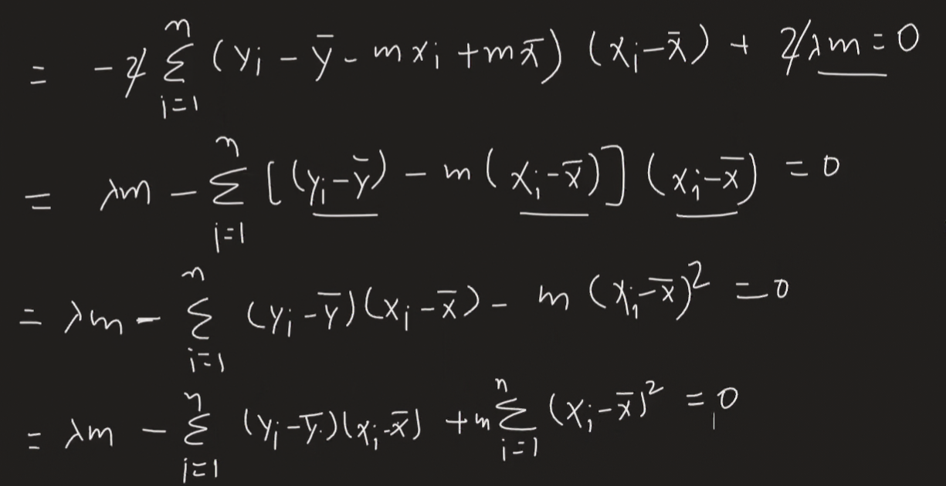

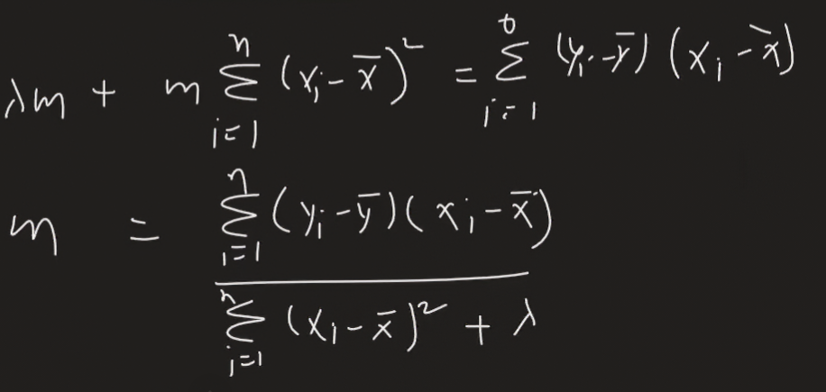

Here m is inversely proportional to lambda.

Ridge Regularization for nD data

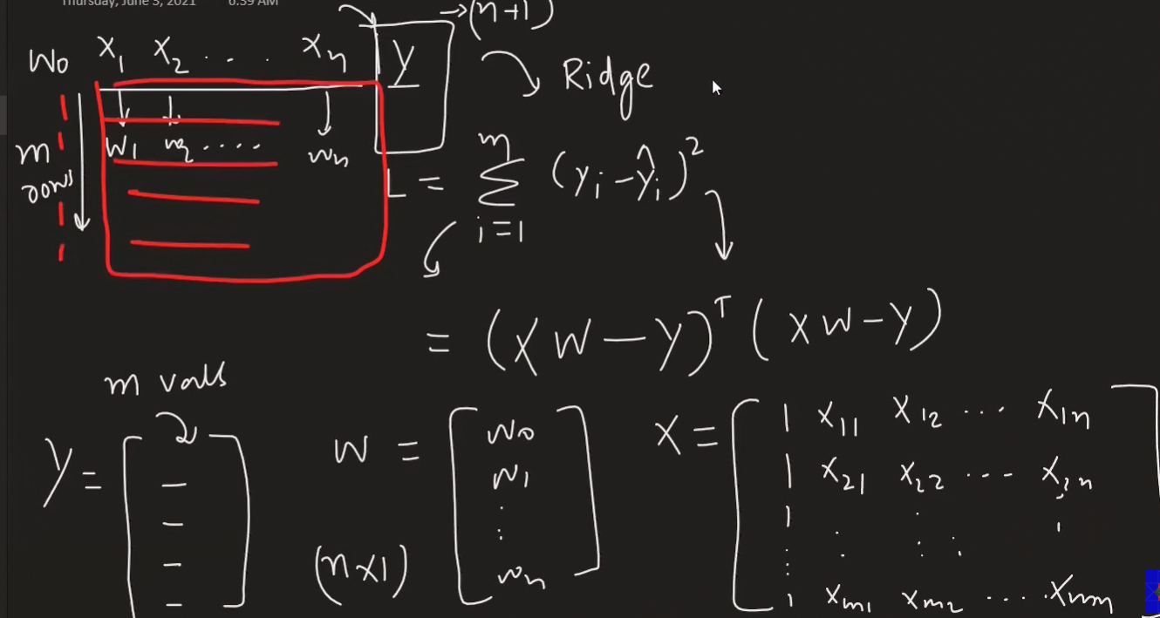

This is the formula et \* e

Adding Ridge regression hyperparameter to it

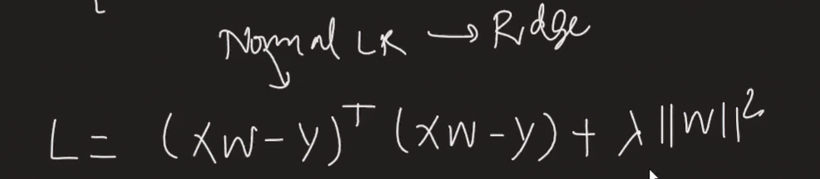

Matrix of w2 can be written as = wt \* w

As it represent the below figure

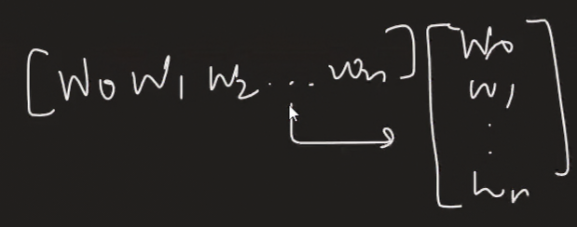



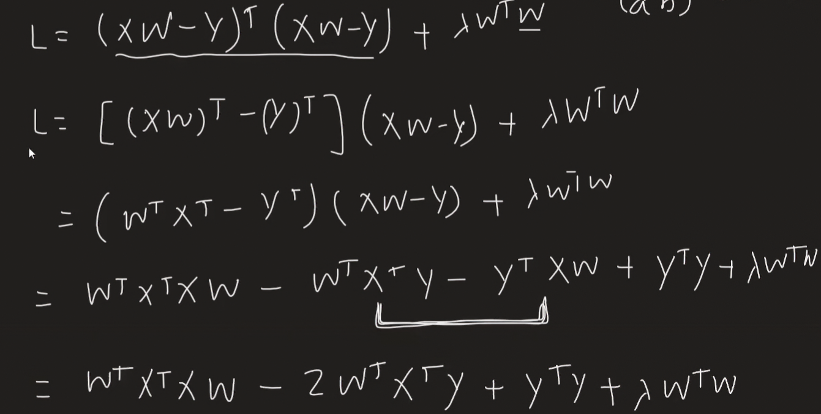

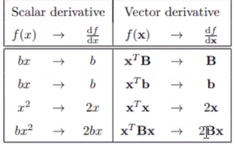

These are some formulae for vector differentiation on upcoming proof

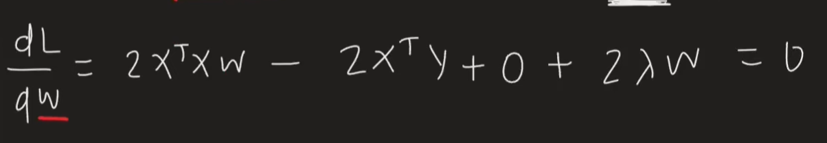

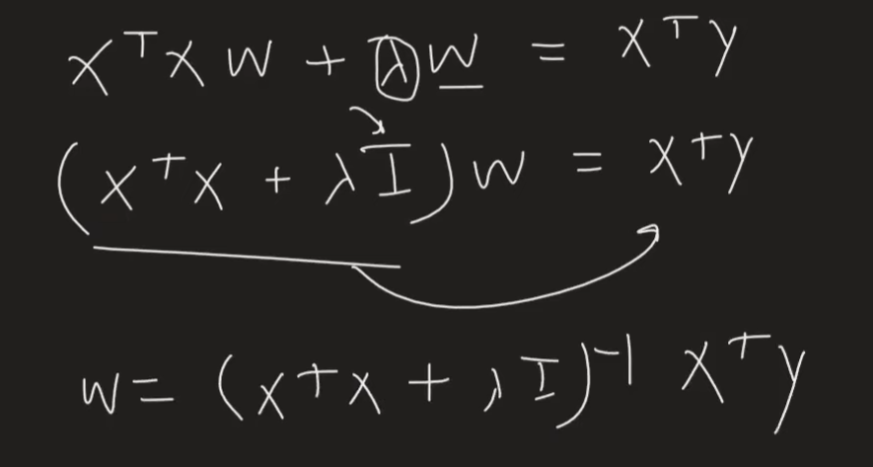

Ridge Regularization using GD:

